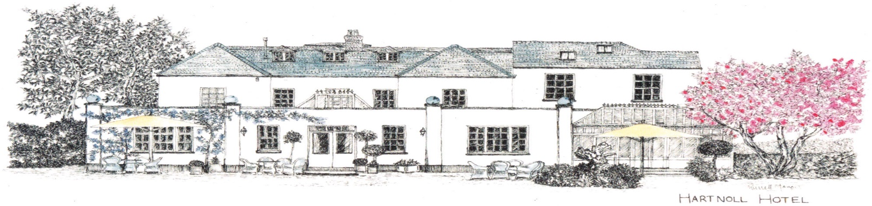

Rotary Festive Menu

2 course £35.00, 3 course £40.00
Including two bottles of wine per table of ten.

To Start
Curried Parsnip Soup with Crispy Onions
(D,C,SD,G)

Chicken & Herb Terrine, Apple & Apricot Chutney, Herb Salad, Sour Dough Toasts
(SD,D,C,E,G)

Severn & Wye Hot Smoked Salmon & Trout, Horseradish Mayonnaise, Spiced Baby Figs, Watercress Salad (F,SD,E,M)



For Main
Roasted Free Range Ballotine of Turkey Breast, Duck Fat Roast Potatoes, Sage & Onion Stuffing,
Chipolata Sausage Wrapped in Bacon with Red Wine Gravy
(G,D,SD,C)

Medium Rare Roasted Dry Aged West Country Rump of Beef, Roast Potatoes,
Yorkshire Pudding & Red Wine Jus (SD,E,G,C,D)

Grilled Fillet of Salmon, Crushed New Potatoes, Wilted Greens, White Wine & Herb Sauce
(F,SD,C,D,M)

Potato Gnocchi, Roasted Butternut Squash, Wild Mushrooms, Kale & Walnut Pesto Salad
(G,D,N)

All Served With Honey Roasted Parsnips, Carrots, Curley Kale, Broccoli and Brussel Sprouts (D,SD)

To Finish
Christmas Pudding with Vanilla Ice Cream, Brandy Sauce, & Red Currant Compote
(D,G,E,SD)

Glazed Lemon Tart with Winter Berries, Mini Meringues & Blackcurrant Sorbet
(E,D,G)

Selection of Homemade Ice Creams & Sorbet
(Chocolate, Honeycomb or Vanilla Ice Cream or Blackcurrant, Lemon or Mango Sorbet)
(D,G,E,SD)

Coffee & Mince Pie (D,G,E)

